Wedding Menu 6

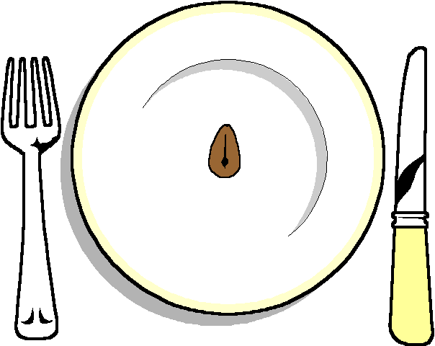

Warwickshire forest blue cheese Soufflé
On a rocket salad
*****

Beef Fillet
With a sherry and Tarragon sauce
Selection of Seasonal Vegetables
Hot New Potatoes

******

Mini homemade Sticky Toffee Pudding
With a pecan sauce

******

Coffee and mints

