Wedding Menu 3

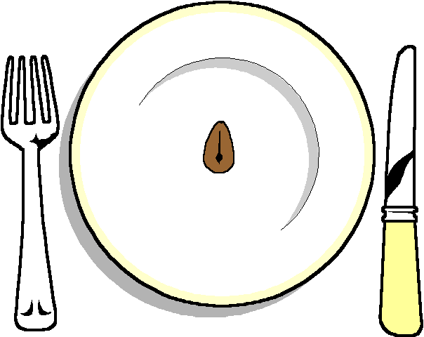

Galantine of Salmon
With a lemon mayonnaise

******

Creamy Pork Stroganoff
Selection of Seasonal Vegetables
Duchess Potatoes

******

Lemon Citron Tart

******

Coffee and Mints

