Wedding Menu 2

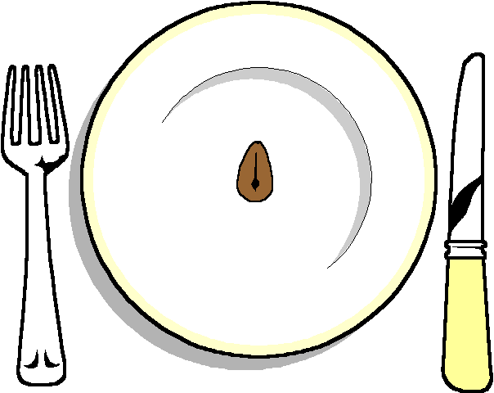

Mango and Brie Parcels
On a bed of Cranberry Sauce

*****
Individual Lamb Shanks
With a mint and onion sauce
Selection of Seasonal Vegetables
Creamy mash Potatoes

******
Pofferoles with Hot Chocolate Sauce
Raspberry Roulade

****

Coffee and Mints

