Wedding Menu 1

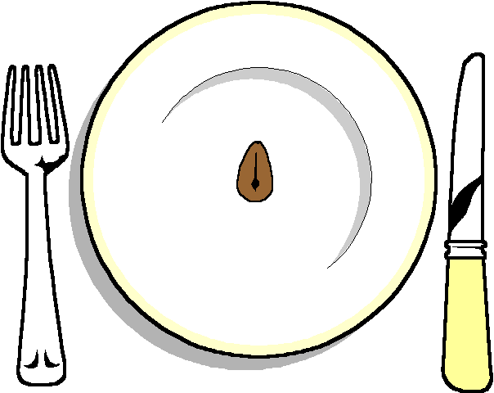

Double Baked Soufflé
With a rocket salad
*****

Stuffed Salmon
With a balsamic Dressing
Garlic Mash
Selection of Vegetables

******

Homemade Bakewell tartlets

******

Coffee and chocolates

