Menu 10

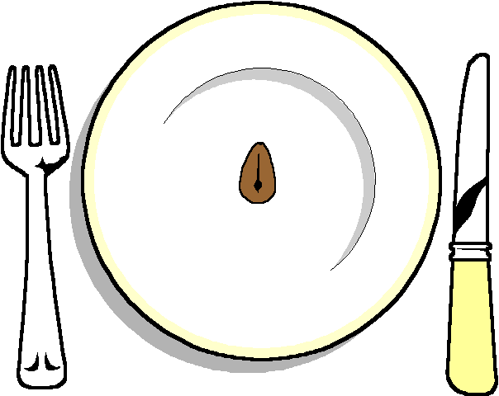

Mushroom and red onion tartlet
Rocket and Balsamic Dressing

*****

Fillet of sea bass
With a parmesan crust and pesto sauce
Selection of Seasonal Vegetables
Mash

******

Homemade Chocolate Mousse
With a sable biscuit

******

Cheese and Biscuits

******
Coffee and mints

