Menu 1

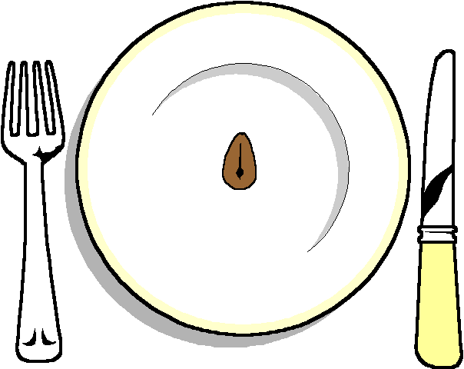

Thai fishcake
On a rocket salad
******

Fillet of Chicken
Stuffed with Bousin Cheese with a red pepper sauce
Selection of Seasonal Vegetables
Hot New Potatoes

******
Lemon Citron Tart

******
Cheese and biscuits

******

Coffee and chocolates

