Menu 1

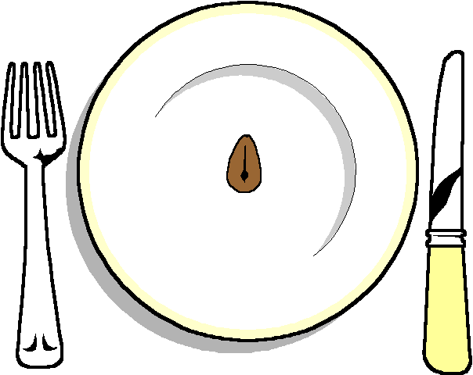

HOT

Pork Stroganoff
Moussaka

******
Mixed Salad
Hot New Potatoes
Or
Vegetables

****

Sticky Toffee Pudds
With a pecan Sauce
Homemade Bakewell tart

*****
Cheese and Biscuits

******
Coffee and mints

