Menu 2

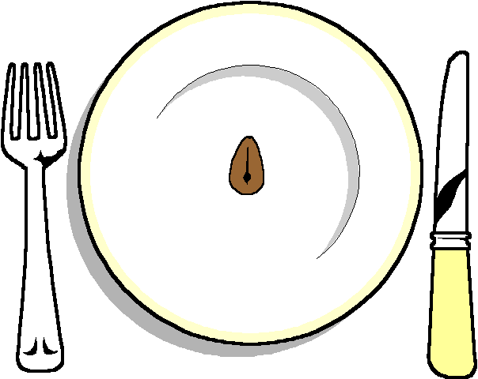

Coq au vin
Beef and Guinness Pie

******
Baked new Potatoes
Selection of Vegetables

******

Lemon Citron Tart
Prifiteroles
With Hot Chocolate Sauce

******
Cheese and biscuits
******
Coffee and chocolates

