Hot and Cold Menu 4

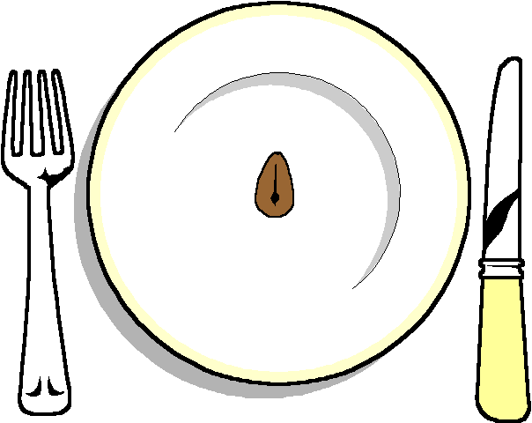

HOT

Coq au Vin
Vegetable Lattice Tart

COLD

Fillet of Beef
Red pepper roulade

******
Selection of 3 Salads
Hot New Potatoes
*****
Selection of ciabatta breads
******
Rich Chocolate Tart
Toffee Roulade

******
Cheese and Biscuits

******
Coffee and chocolates

