Hot and Cold Menu 1

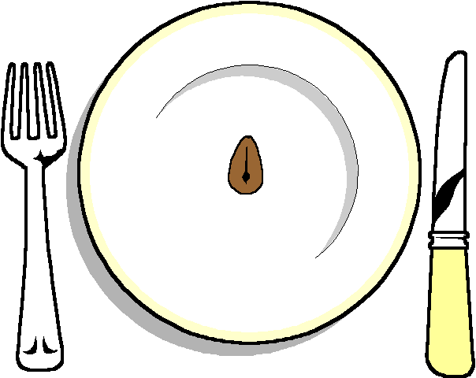

HOT
Chicken Fillets with a Veronique Sauce
Beef and Guinness Pie

COLD
Dressed Salmon
Watercress Roulade
******
Selection of 3 Salads
Hot New Potatoes
*****
Selection of Rolls
******

Lemon Citron Tart
Banoffee Pie

******
Cheese and Biscuits

******
Coffee and chocolates

