Christmas Dinner

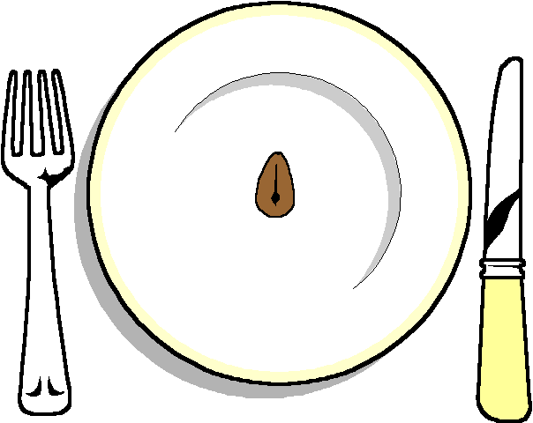

HOT

Turkey
Roast potatoes
Selection of Vegetables
(Sprouts, carrots, parsnips)
All the trimming
Vegetarian option

*******
Homemade Christmas pudding
With Brandy sauce

******

Coffee and tea
With homemade mince pies

Crackers included

