Canapés Menu

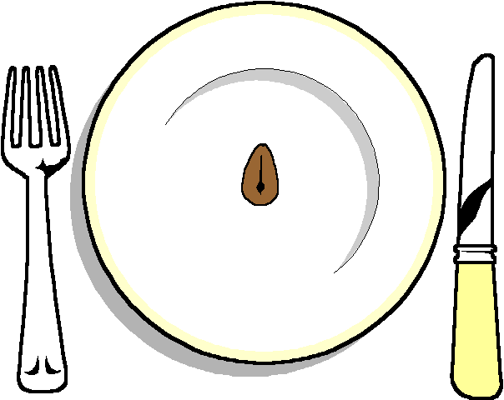

Duck in Filo Pastry Baskets with a Plum Sauce
Cucumber and spring onion
Salmon Pinwheels
Sausages in Honey and Sesame seeds
Mini Watercress and Trout Roulade
Mini Homemade Quiches
Chicken Sate with a peanut sauce
Prawns in File Pastry
Feta Cheese Bundles
Camembert Puffs
Devils on Horseback
Open Salmon Canapés
Chicken Livers on sticks
Asparagus Rolls
Filo Pastry Baskets filled with
Asparagus and Hollandaise sauce
Goat’s cheese and roast pepper mint wraps
Tiny Parmesan and Rosemary Shortbreads
Tomato and Brie on sticks
Mini Yorkshire Puddings
Avocado and goat cheese Crustini
Crustini with a pesto and sundried tomato topping
Open salmon Canapés
Scampi with tartar sauce
Mini small sandwiches
Please pick 5 different canapés

