Afternoon Tea 2

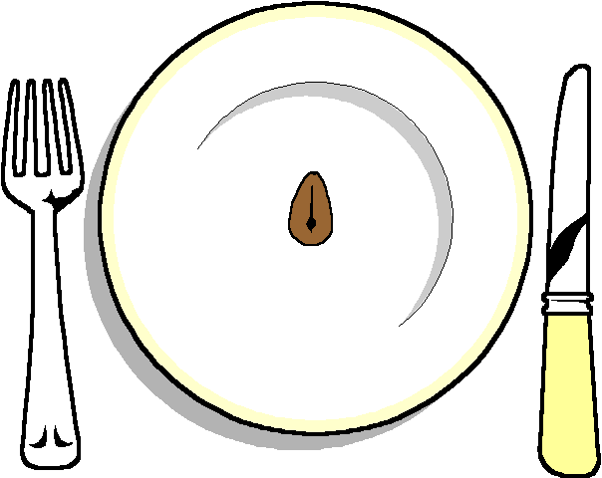

******

Selection of homemade sandwiches
Egg and cress Mayonnaise
Smoked Salmon
Many more fillings

******
Homemade Cheese straws

******
Mini vol au vents

******
Mini Homemade Rockfort and walnut tartlets

******
Selection of Cup cakes
And Fairy Cakes

******
Tea and coffee

