Afternoon Tea 1

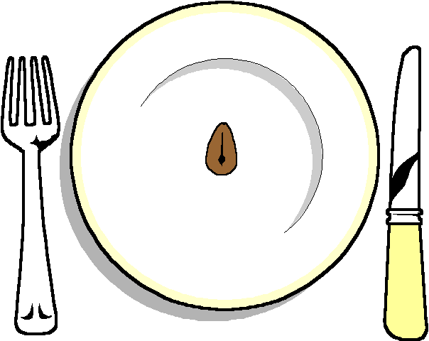

******

Selection of homemade sandwiches
Egg and cress Mayonnaise
Smoked Salmon

******
Homemade mini Scones cream and jam

******
Homemade Shortbread
Flapjack

******
Mini Homemade Quiches
******

Homemade cakes (pick two)
Coffee cake
Victoria Sponge
Carrot cake
Fruit Cake
Chocolate Cake

******
Tea and coffee

