COLD MENU 3

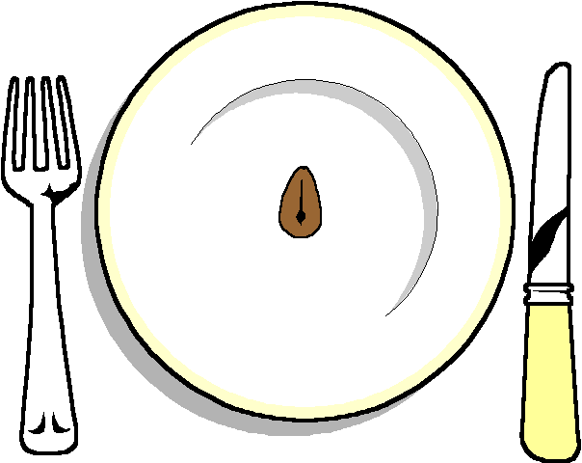

******
Chicken and Mango pie

Smoked Trout
Goats Cheese and Basil Puff
Stuffed Tomatoes

******
Selection of Rolls

******
Selection of 3 Salads

******

Hot New Potatoes

******
Raspberry and Hazelnut Meringue
Individual Lemon cheesecake

******
Cheese and biscuits
******
Coffee and Tea

