COLD MENU 2

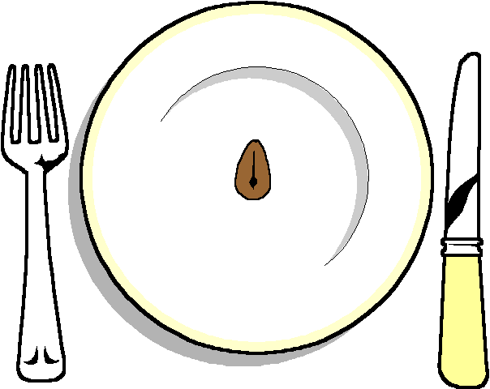

******

Chicken Coronation

Stilton and Walnut Tartlet
Watercress and Prawn Roulade
Honey Roast Ham

******
Selection of Rolls

******
Selection of 3 Salads

******

Hot New Potatoes

******
Rich Chocolate Tart
Raspberry Roulade

******

Cheese and Biscuits

******
Coffee or Tea

