COLD MENU 1

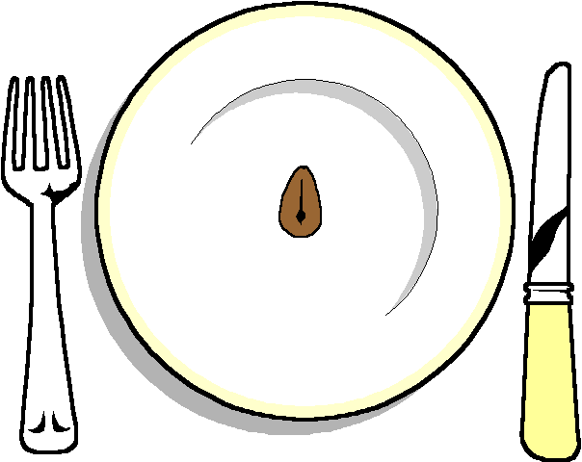

******

Dressed Salmon
(With cucumber and Prawns)
Stuffed Chicken
Gruyere and Herb Roulade
Roast beef
******
Selection of Rolls

******
Selection of 3 Salads

******
Hot New Potatoes

******
Fruit Pavalova
Lemon Citron Tart

******
Cheese and Biscuits

******
Coffee or tea

