BBQ Menu 2

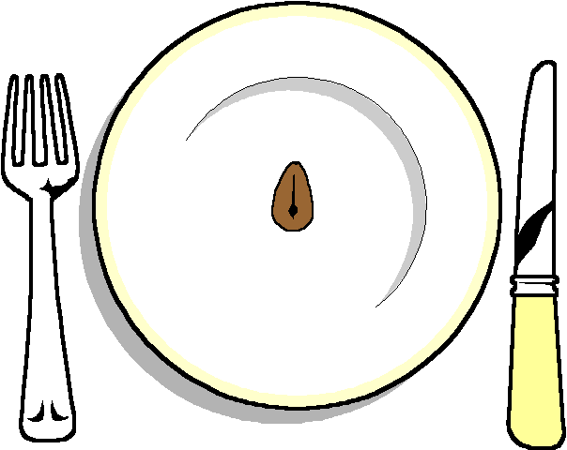

Canapés

******

Homemade lamb and mint burgers
Homemade Veggie Kebabs
Fillet steak
Mini sweet corn
******

Selection of 3 Salads
Selection of breads
Hot Roasted Potatoes
BBQ Sauces
Dressing for salads
****

Chocolate Roulade
Fruit Pavola
Lemon Citron Tart

******

